Practical - 5
Practical Title: Registration Form with Frontend Validation and User-
Friendly Error Handling

Problem Definition: Create a student registration form with HTML5 input types and JavaScript
validation for name, email, mobile number, password, confirm password, course, year, gender, and
terms acceptance. Use Regular Expression for validations.

Theory :

1. Are correct input types and attributes used?
Yes, correct input types and attributes are used. Text is used for names, email for email addresses,
password for passwords, and the required attribute ensures that mandatory fields cannot be left empty.

2. Are validation errors displayed near the relevant fields?
No. Validation errors are currently displayed through alert messages rather than near the relevant input
fields.

3. Is password strength checked?
Yes, password strength is checked using JavaScript validation with minimum length and character
requirements.

4. Is the form accessible using keyboard and screen-reader-friendly labels?
Partially. Keyboard access is supported, but labels should be linked to their corresponding input fields
using the for attribute for better screen-reader accessibility.

- Evidence of Work (Screenshots):
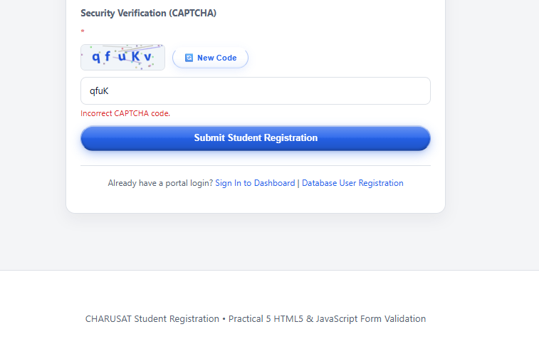
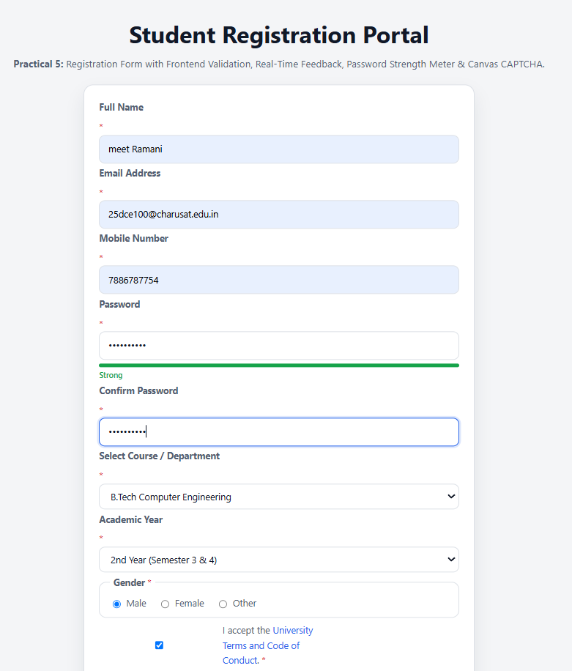

Repository Link :-
https://github.com/meet-3834/Student-Hub/tree/main/FINAL%20Submission

- Learning Outcomes:
I am able design accessible forms with robust client-side validation.

Faculty Remarks: (Keep this blank for faculty)

